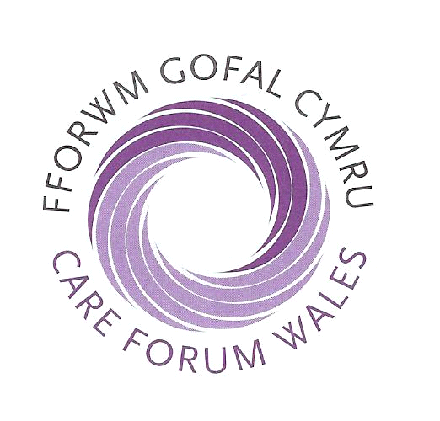

Social Care Essential Update Seminars

Care Forum Wales is hosting a series of Essential Update Seminars for registered providers,

These important twice yearly seminars will provide delegates with an informative, focused and interactive day that will ensure Registered Providers, Registered Managers and Senior Staff who are responsible for providing social care in Wales will leave the seminar with the very latest information on the opportunities that exist for your organisation to stay ahead of the rest.

The seminars provide incredible value for money as both an awareness raising and CPD learning opportunity. Seminar handout information, refreshments and buffet are included in the cost. (Certificates of attendance are available on the day by request).

Please indicate the number of delegate places required in the box for your preferred venue. All seminars will commence at 9.30am and end at approximately 3.15pm.

South West Wales North West Wales
14th April 2015 10th March 2015
Nat Botanic Garden of Wales,Carmarthen Conwy Business Centre, Conwy

South East Wales North East Wales
16th April 2015 T 17th March 2015
University of South Wales, Treforest Springfield Hotel, Holywell

Please photocopy this booking form if you require more than two places.
Name Designation

Name Designation

Name of organisation

CFW membership number (if applicable)

Address

Post code

Tel: Fax: Email

Main areas of interest (please select)

Care Home Domiciliary Care Nursing Services Dementia Mental Health

Children &Young People Learning Disability Older People Physical Disability

Education Training Other please specify _____________________________

BOOK BEFORE TO GET YOUR DISCOUNT
PLEASE CONFIRM IF YOU HAVE ANY SPECIAL DIETARY REQUIREMENTS

Cost per delegate: £35 to CFW Members (if booked before 01/03/15)
Cost per delegate: £40 to CFW Members

Cost per delegate: £85.00 - Non CFW member (if booked before 01/03/15)
Cost per delegate: £90.00 - Non CFW member
Total Remittance £__________

Cheque enclosed __________
Payable to - Care Forum Wales

Details for Bacs payments as follows: RBS-Account no-23154717
Sort code-16-00-15
Return with remittance to: Social Care Essential Update Seminars,
PO Box 2195, Wrexham, LL13 7WL

PLEASE NOTE: Substitutions can be made anytime, cancellations up to twenty one days before the event will incur a £10.00 administration charge. No refund shall be given if cancellation is made less than twenty one days prior to the date of the event.

